Friday, April 10, 2026
1:20 AM
📘 NNFX Money Management Algorithm

🧭 1. Overview
The No Nonsense Forex money management model is designed to:
- Control downside risk through fixed fractional risk
- Secure profits early via partial exit (scaling out)
- Maximize trend gains using a runner position
- Adapt dynamically using ATR-based volatility

⚙️ 2. Core Principles

📊 2.1 Fixed Risk Per Trade
- Total risk per trade: 2% of account equity
- Split into:
  - Order #1 → 1% risk
  - Order #2 → 1% risk
👉 Ensures:
- Controlled exposure
- Consistent position sizing

📐 2.2 Volatility-Based Stops (ATR)
All stop-loss and management rules are based on ATR (Average True Range):
Parameter | Value
Initial SL | 1.5 × ATR
TP (Order #1) | 1 × ATR
TP (Order #2) | None (runner)

🧩 3. Trade Structure

📌 Dual-Position Model
Order | Role | Objective
Order #1 | Scalp / Secure Profit | Lock in gains early
Order #2 | Runner | Capture extended trend

🔄 4. Trade Lifecycle

📊 UML Activity Diagram (Lifecycle)

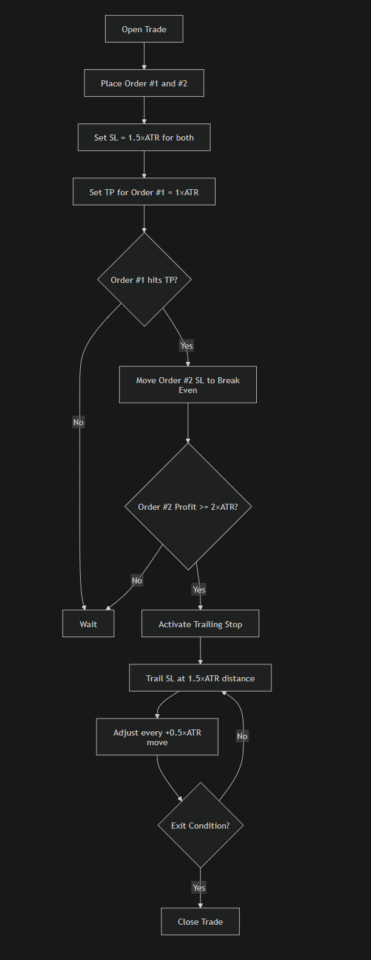

Code </> Mermaid
flowchart TD
A[Open Trade] --> B[Place Order #1 and #2]
B --> C[Set SL = 1.5×ATR for both]
C --> D[Set TP for Order #1 = 1×ATR]

D --> E{Order #1 hits TP?}
E -->|Yes| F[Move Order #2 SL to Break Even]
E -->|No| G[Wait]

F --> H{Order #2 Profit >= 2×ATR?}
H -->|Yes| I[Activate Trailing Stop]
H -->|No| G

I --> J[Trail SL at 1.5×ATR distance]
J --> K[Adjust every +0.5×ATR move]

K --> L{Exit Condition?}
L -->|Yes| M[Close Trade]
L -->|No| J

💰 5. Risk Management Model

📉 5.1 Position Sizing Logic
- Risk per order is calculated using:
  - Account equity
  - Stop-loss distance (ATR-based)
👉 Result:
- Position size adjusts automatically to volatility

📌 Key Behavior
- Larger ATR → smaller position size
- Smaller ATR → larger position size

✂️ 6. Scaling Out (Partial Take Profit)

📊 Mechanism
- Order #1 closes at +1×ATR
- Locks in guaranteed profit
- Reduces overall trade risk

🧠 Purpose
- Converts trade into low-risk / risk-free scenario
- Allows second position to run freely

📊 UML Sequence (Scaling Out)

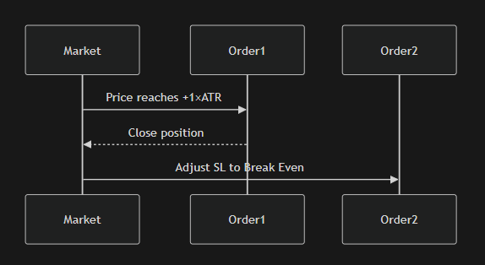

Code </> Mermaid
sequenceDiagram
participant Market
participant Order1
participant Order2

Market->>Order1: Price reaches +1×ATR
Order1-->>Market: Close position

Market->>Order2: Adjust SL to Break Even

🛡️ 7. Break-Even Mechanism

📌 Trigger
- Activated after Order #1 hits TP

📌 Action
- Move Order #2 Stop Loss → Entry Price

🧠 Result
- Trade becomes risk-free

📈 8. Trailing Stop Strategy

📊 Activation Condition
- When Order #2 reaches +2×ATR profit

⚙️ Trailing Rules
Condition | Action
Profit ≥ 2×ATR | Start trailing
Every +0.5×ATR | Adjust SL
SL Distance | Maintain 1.5×ATR

🧠 Behavior
- Locks in profits gradually
- Allows trend continuation
- Avoids premature exits

📊 UML Activity (Trailing Stop)

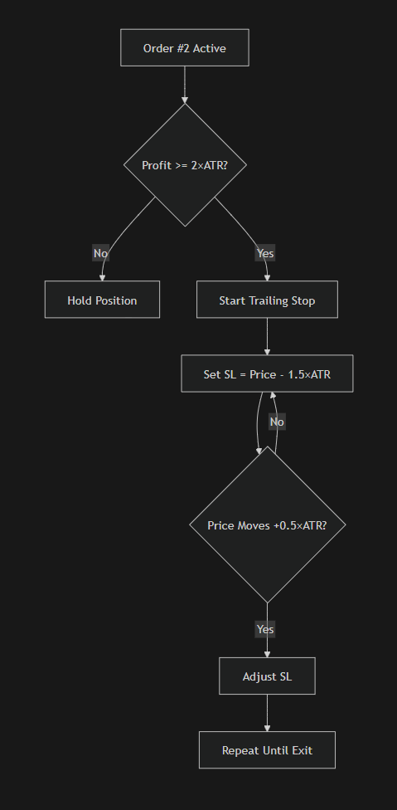

Code </> Mermaid
flowchart TD
A[Order #2 Active] --> B{Profit >= 2×ATR?}
B -->|No| C[Hold Position]
B -->|Yes| D[Start Trailing Stop]

D --> E[Set SL = Price - 1.5×ATR]
E --> F{Price Moves +0.5×ATR?}
F -->|Yes| G[Adjust SL]
F -->|No| E

G --> H[Repeat Until Exit]

🚪 9. Exit Integration

Exit Conditions (applies to runner)
- Exit indicator signal
- Baseline cross
- Opposite C1 signal
- Stop-loss hit

📌 Interaction with Money Management
- Trailing stop works in parallel with exit signals
- Whichever triggers first → trade closes

🧠 10. Behavioral Summary

✔️ Strengths
- Converts trades into risk-free positions early
- Maximizes trend capture potential
- Fully volatility adaptive
- Reduces emotional decision-making

⚠️ Considerations
- Requires precise ATR calculation
- Needs accurate position sizing
- Trailing stop must be state-aware

🏗️ 11. UML Class Design (Architecture)

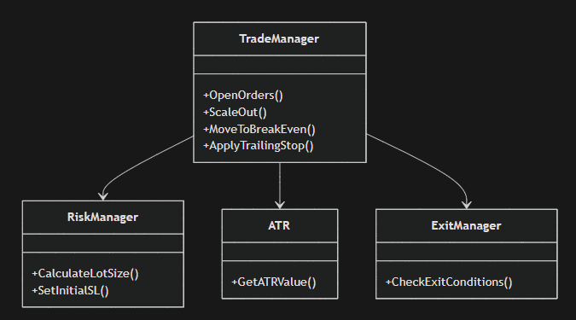

classDiagram
class RiskManager {
+CalculateLotSize()
+SetInitialSL()
}

class TradeManager {
+OpenOrders()
+ScaleOut()
+MoveToBreakEven()
+ApplyTrailingStop()
}

class ATR {
+GetATRValue()
}

class ExitManager {
+CheckExitConditions()
}

TradeManager --> RiskManager
TradeManager --> ATR
TradeManager --> ExitManager

🎯 12. Key Takeaways

- NNFX money management is built on 3 phases:
🧱 Phase 1 — Risk Control
- Fixed 2% risk
- ATR-based SL

✂️ Phase 2 — Profit Securing
- Scale out at 1×ATR
- Move to break-even

🚀 Phase 3 — Profit Maximization
- Trail stop after 2×ATR
- Let runner capture trend

🚀 Final Insight (For Your EA)
To implement this correctly in your system:
👉 You must track trade state transitions:

OPEN → PARTIAL CLOSED → BREAK EVEN → TRAILING → EXIT
👉 This is NOT just math — it’s a state machine

